A screenshot of a cell phone screen with text

Description generated with very high confidence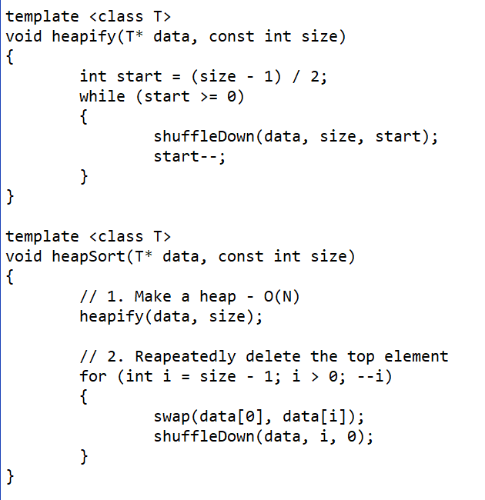A screenshot of a cell phone

Description generated with very high confidence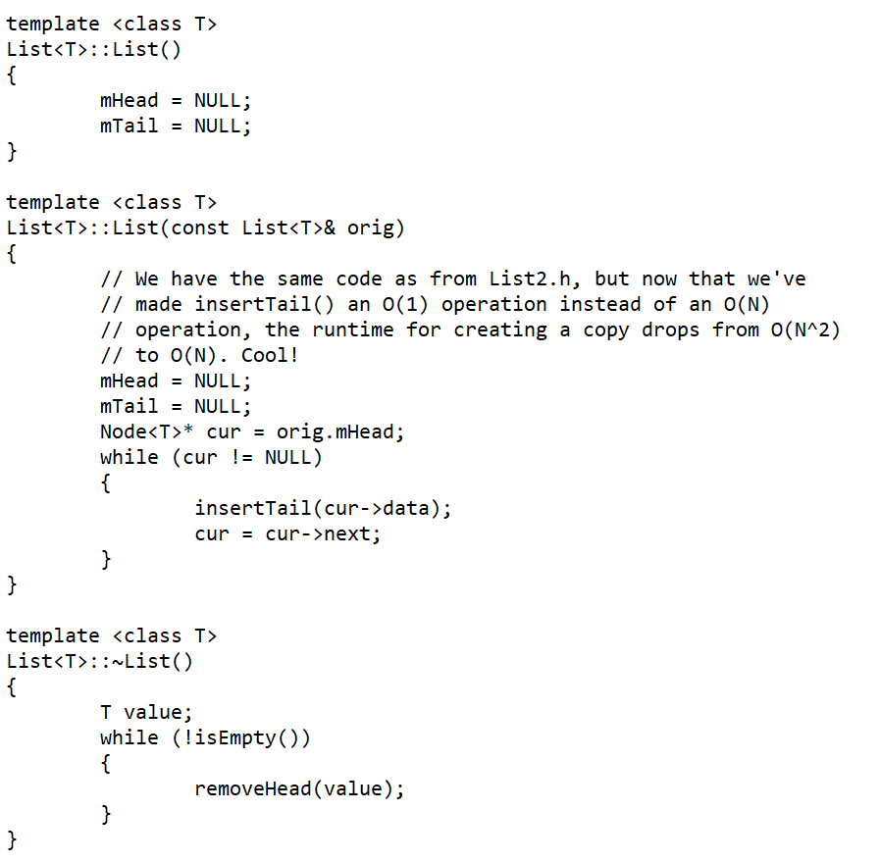

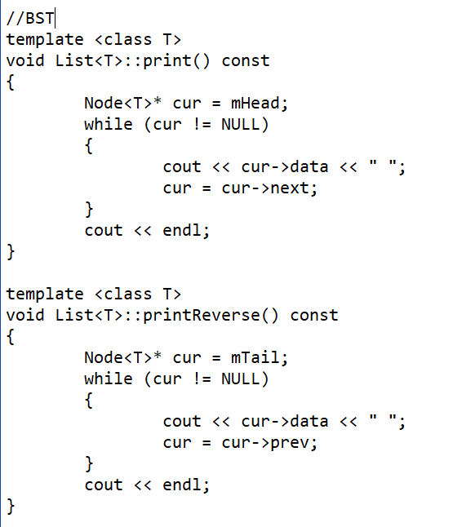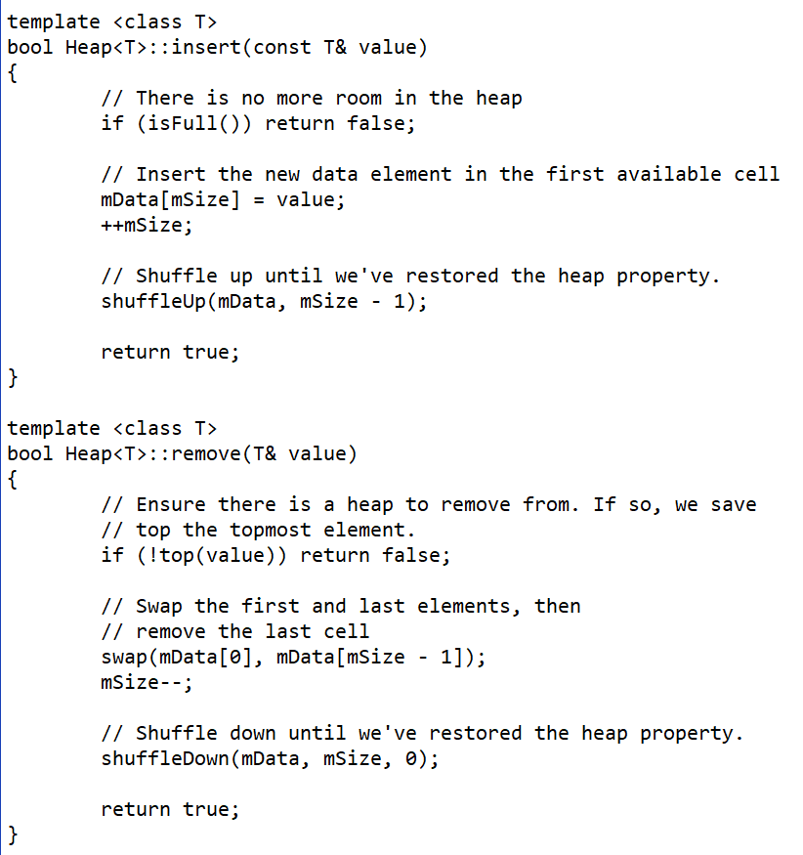

**Vector/Array: insert** – O(1) at end, O(N) at middle, **remove** – O(N), **search** – O(N) unsorted, O(logN) sorted

**Linked List: insert** – O(N), **remove** – O(N), **search** – O(N)

**BST: insert** – O(logN), **remove** – O(logN), **search** – O(logN)

**Hash Table: insert** – O(1), **remove** – O(1), **search** – O(1) separate chaining is with Linked List

Heaps are complete and balanced, have the heap property, and max value is on top, can only remove head

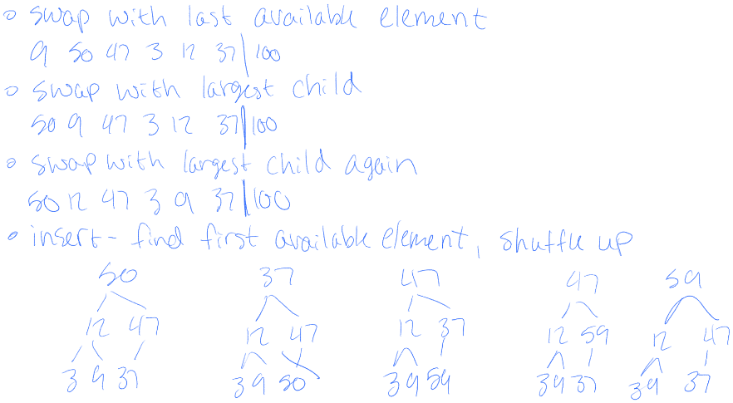

BST is like Linked List but with 2 ->next

Remove head by swapping with successor then reroute with leaf then delete

If balanced insertion is O(logN), otherwise its O(N)

Queue – remove head, insert tail or remove tail, insert head

Stacks can only access top

Pop to remove top, push to add to top, top to view top but cant change

No binary search for Linked List